- INTRODUCTION

  - Overview
India’s agriculture cultivation, providing a comprehensive visual exploration of key aspects and trends in the agricultural sector. Through the visual representations, readers can gain valuable insights into crop production, seasonal variations, regional distribution, and overall production trends. These visualizations enable intuitive analysis, allowing stakeholders to uncover patterns, identify areas of growth or concern, and make data-driven decisions.

  - Purpose
By this project not only presents the data in a visually appealing manner but also provides an interactive experience for readers to explore the intricacies of India’s agricultural cultivation. To Extract the Insights from the data and put the data in the form of visualizations, Dashboards and Story we employed Tableau tool.

- PROBLEM DEFINITION & DESIGN THINKING
2.1 Empathy Map
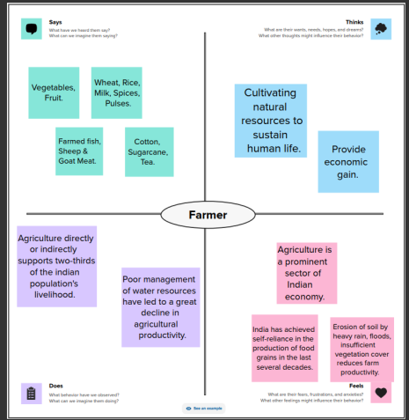
2.2 Ideation & Brainstorming Map
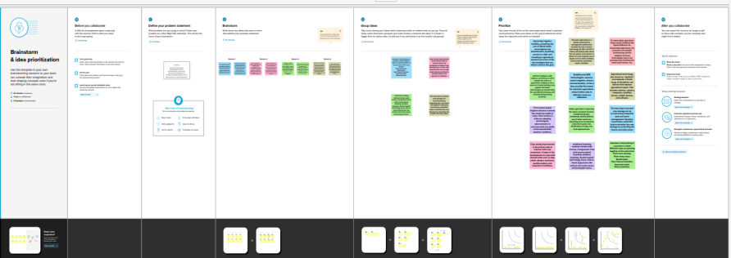
- RESULT
Output of the Project
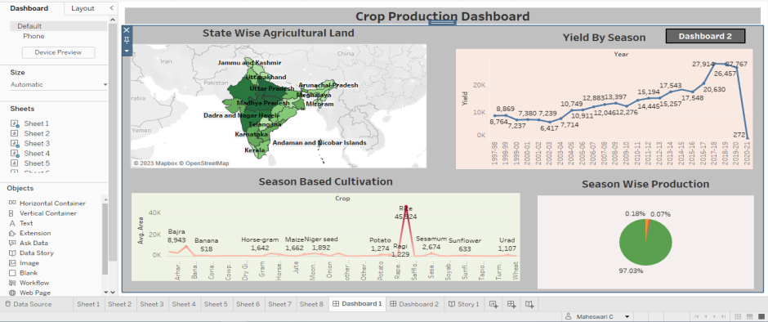
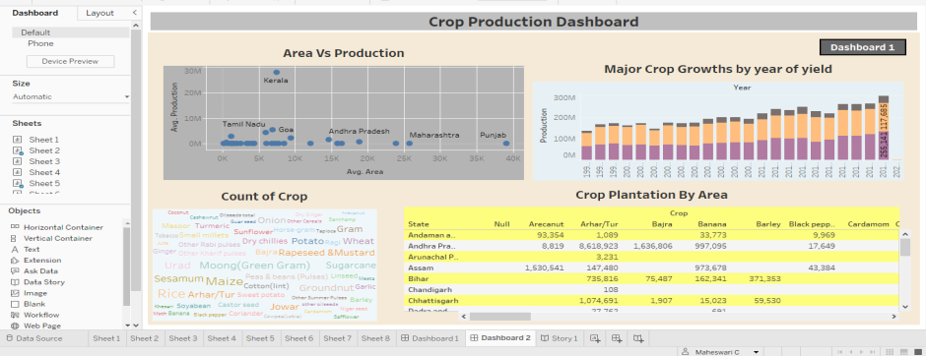
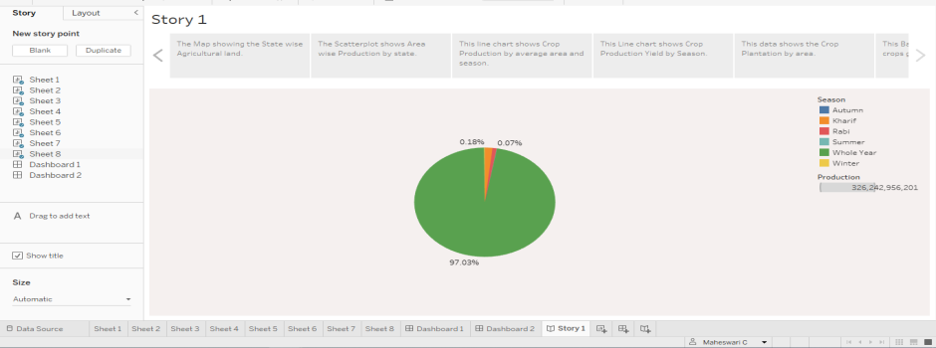

- ADVANTAGES & DISADVANTAGES

Advantages:
- This Project examines the historical context of agricultural practices in India.
- Highlights the role of government policies and initiatives in supporting the sector’s growth and development.
- The survey explores the diversity of crops cultivated across different regions, along with trends in production and the impact of climate variability.
- It also addresses the adoption of technology and innovation in agriculture, along with the challenges faced by farmers and potential research gaps.
Disadvantages:
- Small and fragmented landholdings, a lack of mechanization, soil erosion, agricultural marketing, and insufficient storage facilities are the main problems in Indian agriculture.

- APPLICATIONS
Some common types of visualizations that can be used to analyses the performance and efficiency of banks include bar charts, line charts, heat maps, scatter plots, pie charts, Maps etc.
5.1 State wise Agricultural Land
5.2 Area Vs Production
5.3 Season based cultivation
5.4 Yield by season
5.5 Crop plantation by area
5.6 Major crops growth year of yield
5.7 Crops
5.8 Season wise production

- CONCLUSION

First, we have to understand the given problem. Then, specify the business problem and collect the process of gathering and measuring information on variables of interest, evaluate outcomes and generate insights from the data. Then, download the data and understand the data, connect dataset with Tableau. After, connect dataset with Tableau, preparing the data for visualization involves cleaning the data to remove irrelevant or missing data. This process helps to make the data easily understandable and ready for creating visualizations to gain insights into the performance and efficiency. Then, the number of unique visualizations that can be created with a given dataset. Some common types of visualizations that can be used to analyses the performance and efficiency of banks include bar charts, line charts, pie charts etc. Once created views on different sheets in Tableau, then pull them into a dashboard. The number of scenes in a story for a data visualization analysis of the performance of banks will depend on the analysis and the specific insights that are trying to be conveyed. Then, publish dashboard, story, and reports to tableau public. Once upload was complete, a browser window will automatically open, displaying your published workbook on Tableau Public.

- FUTURE SCOPE
My Future scope is nothing but, more features to add on tableau like download option for download the project. Then, it takes more times to open. So, make it is easy to operate.

